Test Case: tc001_SPX_Dev5_Crear_Nueva_Linea_Requisicion_Spot_Tipo_Cobro_CC
Step 1 - Enter username and password and click to button Enter : Credentials Entered
Image file-name: QC_Testing-tc001_SPX_Dev5_Crear_Nueva_Linea_Requisicion_Spot_Tipo_Cobro_CC-1790176756972

Step 2 - Select to UEN and Access to Spot Buy Requisitions : UEN Correctly selected and Correct access
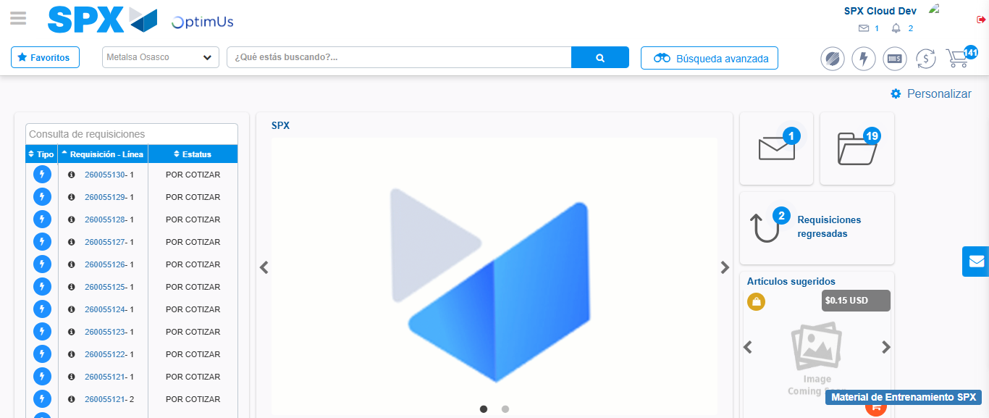Image file-name: QC_Testing-tc001_SPX_Dev5_Crear_Nueva_Linea_Requisicion_Spot_Tipo_Cobro_CC-1790176780368

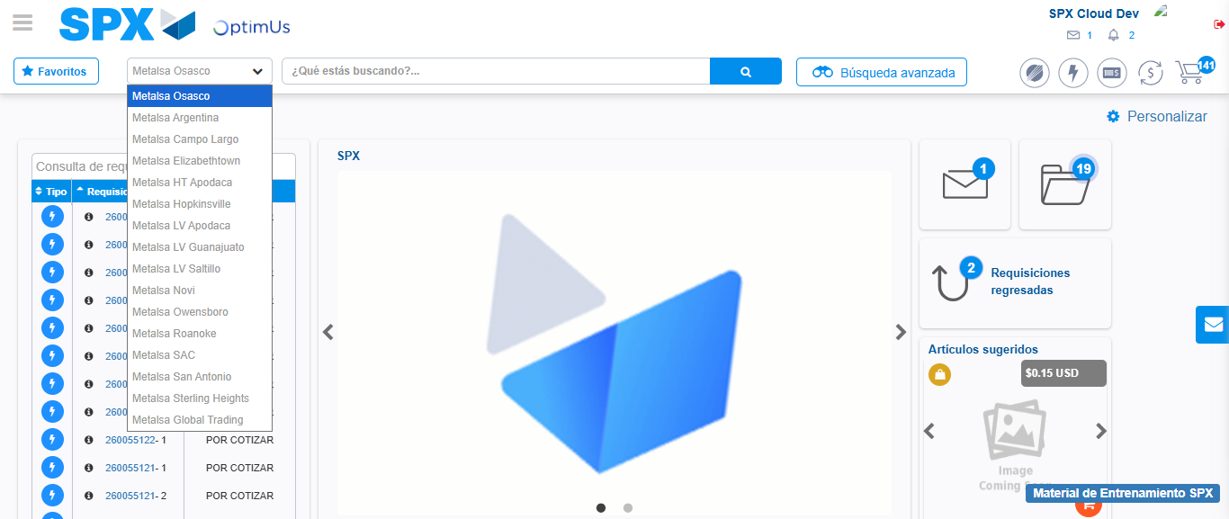Image file-name: QC_Testing-tc001_SPX_Dev5_Crear_Nueva_Linea_Requisicion_Spot_Tipo_Cobro_CC-1790176780898

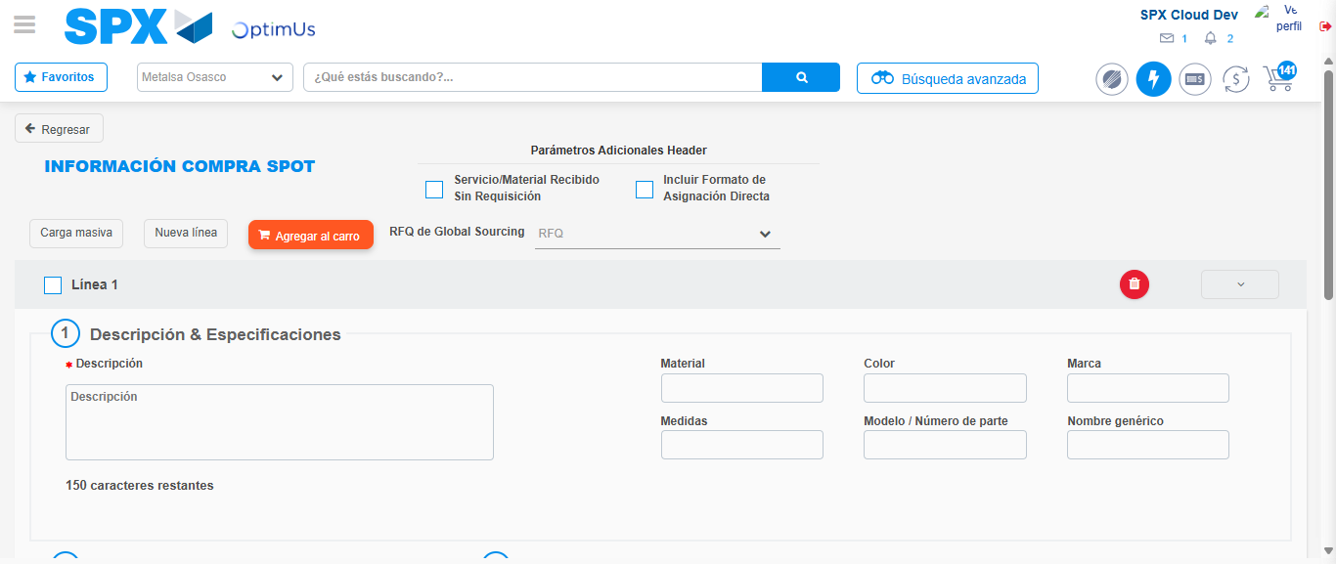Image file-name: QC_Testing-tc001_SPX_Dev5_Crear_Nueva_Linea_Requisicion_Spot_Tipo_Cobro_CC-1790176785799

Step 3 - Data Capture Spot Buy Requisition: Data captured correctly
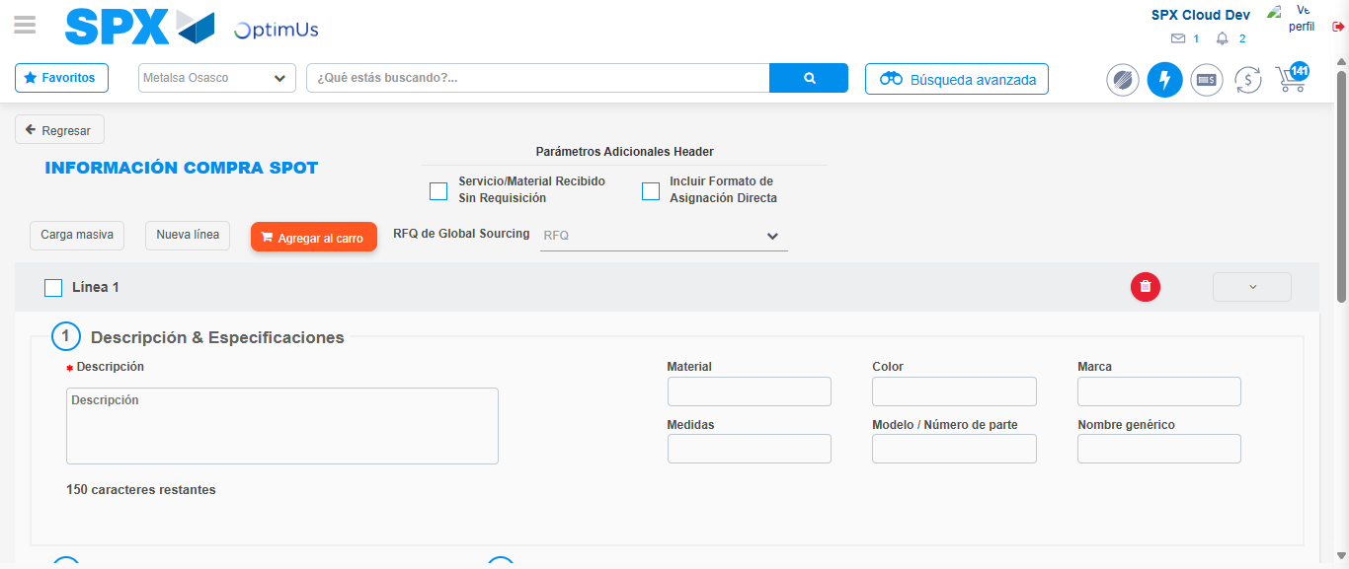Image file-name: QC_Testing-tc001_SPX_Dev5_Crear_Nueva_Linea_Requisicion_Spot_Tipo_Cobro_CC-1790176786023

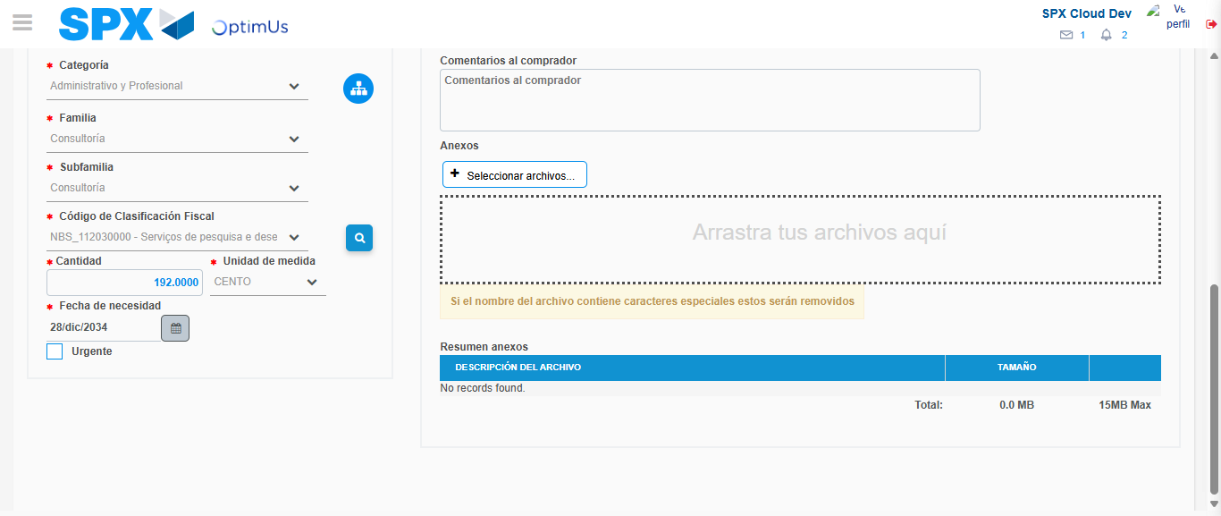Image file-name: QC_Testing-tc001_SPX_Dev5_Crear_Nueva_Linea_Requisicion_Spot_Tipo_Cobro_CC-1790176802427

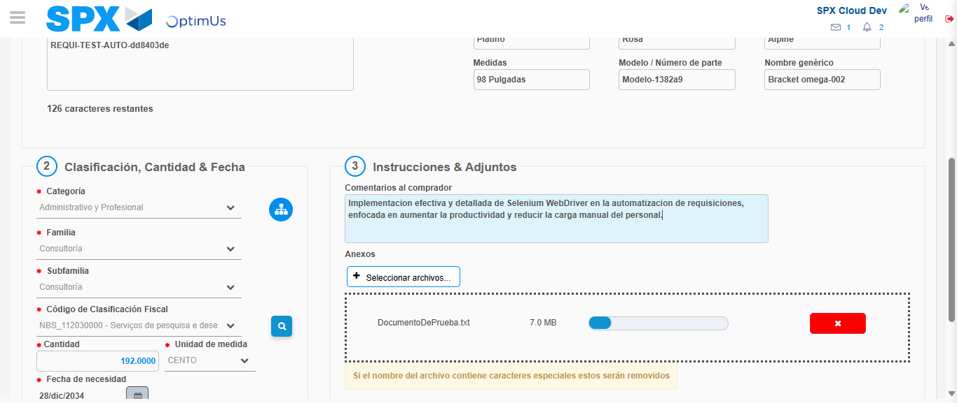Image file-name: QC_Testing-tc001_SPX_Dev5_Crear_Nueva_Linea_Requisicion_Spot_Tipo_Cobro_CC-1790176803236

Step 4 - Add new line and data capture second line: Line add correctly
Image file-name: QC_Testing-tc001_SPX_Dev5_Crear_Nueva_Linea_Requisicion_Spot_Tipo_Cobro_CC-1790176786023

Image file-name: QC_Testing-tc001_SPX_Dev5_Crear_Nueva_Linea_Requisicion_Spot_Tipo_Cobro_CC-1790176802427

Image file-name: QC_Testing-tc001_SPX_Dev5_Crear_Nueva_Linea_Requisicion_Spot_Tipo_Cobro_CC-1790176803236

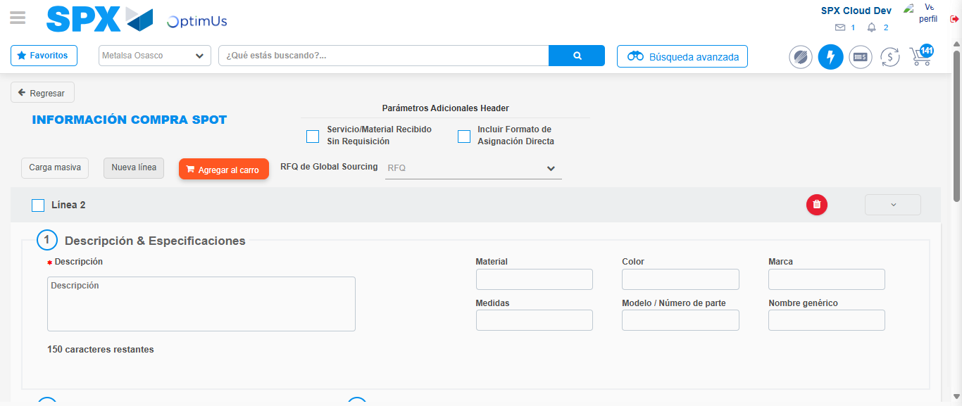Image file-name: QC_Testing-tc001_SPX_Dev5_Crear_Nueva_Linea_Requisicion_Spot_Tipo_Cobro_CC-1790176805506

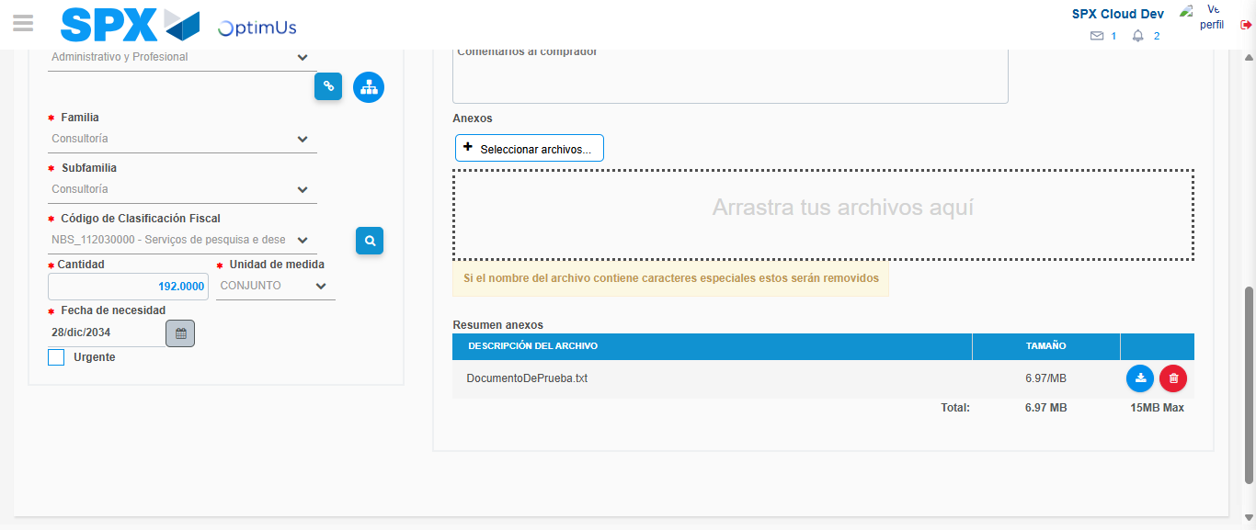Image file-name: QC_Testing-tc001_SPX_Dev5_Crear_Nueva_Linea_Requisicion_Spot_Tipo_Cobro_CC-1790176824454

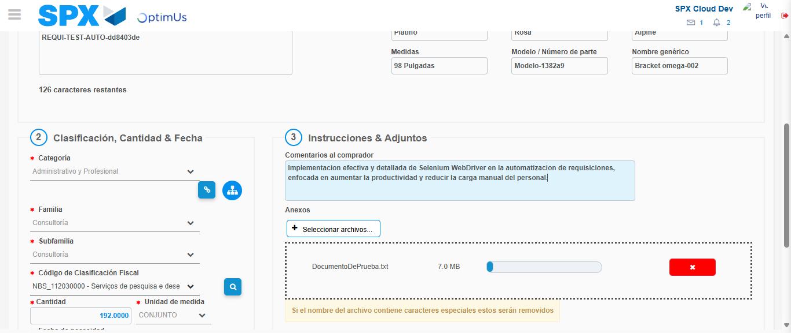Image file-name: QC_Testing-tc001_SPX_Dev5_Crear_Nueva_Linea_Requisicion_Spot_Tipo_Cobro_CC-1790176825219

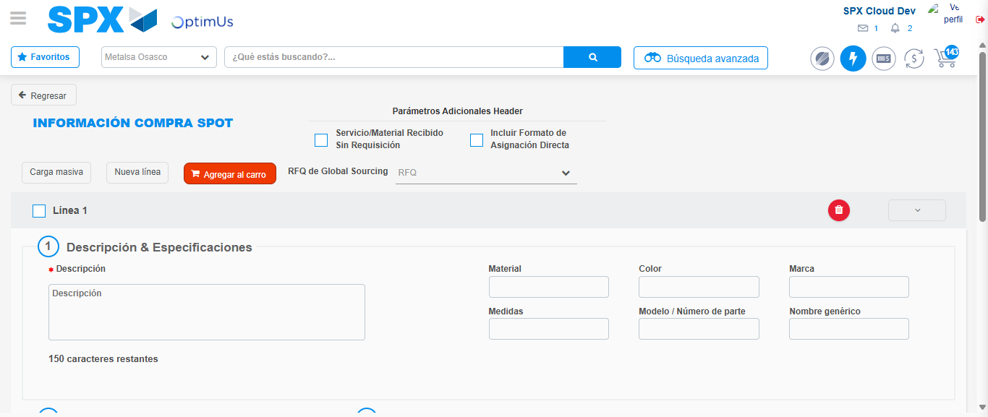Image file-name: QC_Testing-tc001_SPX_Dev5_Crear_Nueva_Linea_Requisicion_Spot_Tipo_Cobro_CC-1790176839844

Step 8 - Return to Main Page SPX : Return to Main Page SPX
Image file-name: QC_Testing-tc001_SPX_Dev5_Crear_Nueva_Linea_Requisicion_Spot_Tipo_Cobro_CC-1790176780368

Image file-name: QC_Testing-tc001_SPX_Dev5_Crear_Nueva_Linea_Requisicion_Spot_Tipo_Cobro_CC-1790176780898

Image file-name: QC_Testing-tc001_SPX_Dev5_Crear_Nueva_Linea_Requisicion_Spot_Tipo_Cobro_CC-1790176785799

Image file-name: QC_Testing-tc001_SPX_Dev5_Crear_Nueva_Linea_Requisicion_Spot_Tipo_Cobro_CC-1790176842042

Image file-name: QC_Testing-tc001_SPX_Dev5_Crear_Nueva_Linea_Requisicion_Spot_Tipo_Cobro_CC-1790176842181

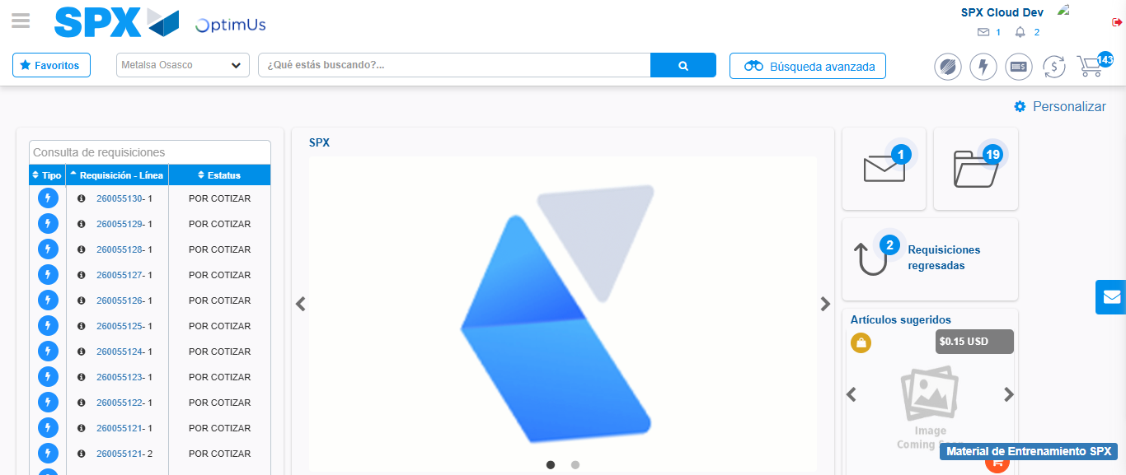Image file-name: QC_Testing-tc001_SPX_Dev5_Crear_Nueva_Linea_Requisicion_Spot_Tipo_Cobro_CC-1790176863190

Step 9 - Log Out : Log Out SPX
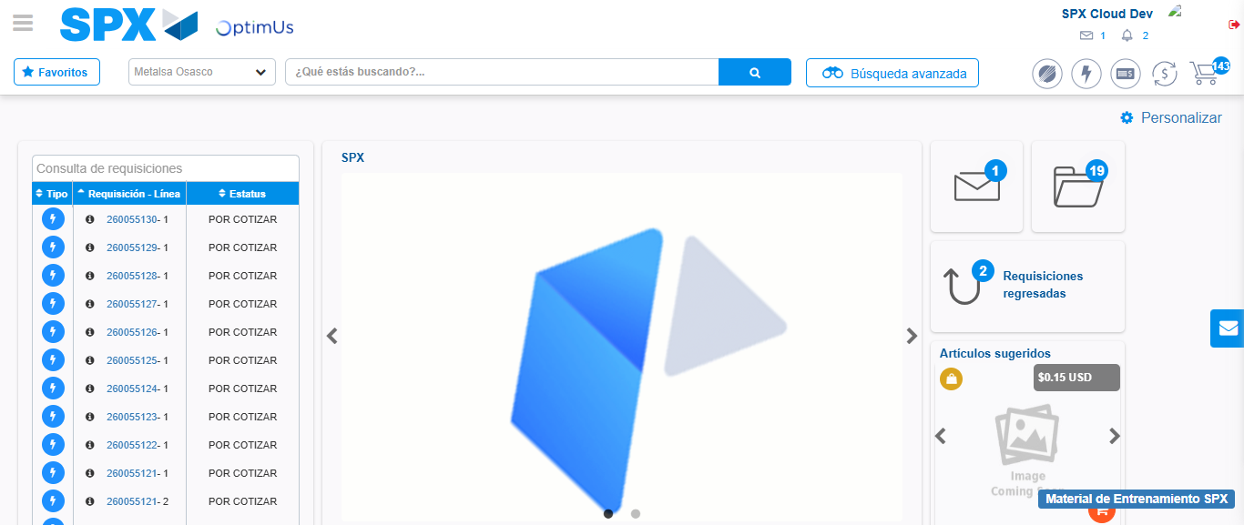Image file-name: QC_Testing-tc001_SPX_Dev5_Crear_Nueva_Linea_Requisicion_Spot_Tipo_Cobro_CC-1790176863481

